EIOPA Solvency II Proof of Concept for MD Open Tables
Version: 1.0
Date: 2014-01-21
About this document
This document presents the motivation and specific details of the Proof of Concept taxonomy distributed alongside the 1.2 Solvency II taxonomy.
Any feedback received before 10th March 2014 will be considered for inclusion in the next public release.

Copyright © European Insurance and Occupational Pensions Authority, 2013
Contact: xbrl@eiopa.europa.eu
INDEX
I Introduction 3
I.1 Background 3
I.2 Motivation 3
II Current Modelling 3
III Proposed modelling 4

Introduction

Background
The Solvency II taxonomy is currently split into a Moderately Dimensional (MD) and a Highly Dimensional (HD) version. Both of these taxonomies model the same reporting requirements, and an automated conversion process between the two is being finalised. For more information about the Solvency II project, and in particular the derivation of MD from HD, see ‘EIOPA Solvency II DPM and XBRL Preparatory Taxonomy Framework Architecture.pdf’ in the taxonomy distribution.

Motivation
The existence of the two different taxonomies gives rise to certain differences in modelling. Throughout the taxonomy, data is modelled with more business meaningful metrics and fewer dimensions in MD than in HD. Additionally, in open tables some data is modelled as facts in MD but as dimensions in HD. This latter difference has a number of disadvantages which could be avoided by following the approach described in this document.

Current Modelling
For example, the following table is an open table containing A1, A2 and A3. When submitting an instance for this table using the current HD taxonomy, a fact would be created whose value is A3, with a ‘PO’ dimension whose value is A2 and an ‘ID’ dimension whose value is A1 (as well as ‘TS’).
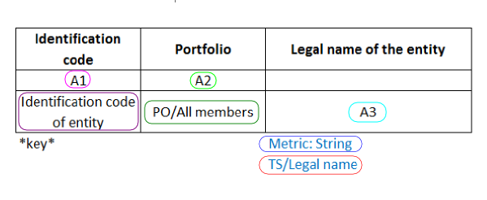
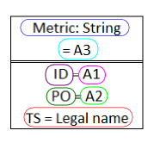
When submitting an instance for this table using the current MD taxonomy, a fact would be created whose value is A3 with a ‘ID’ dimension whose value is A2 but no ‘PO’ dimension. A second fact would be created whose value is A1, with the same ‘ID’ dimension. Both of these would use derived MD metrics.
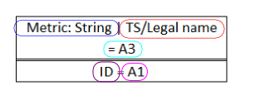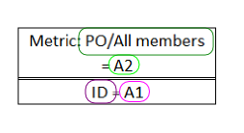

Proposed modelling
As the Proof of Concept only affects the MD taxonomy, no changes will be required to instances created for the HD taxonomy if the Proof of Concept proposal is accepted.
Under the Proof of Concept proposals, a single fact would be created for a MD instance using the ‘PO’ dimension as in the HD. For this fact, the only difference between MD and HD within the Proof of Concept would be the movement of the ‘TS’ dimension into the metric.
Only data items which are modelled as a fact in MD and a dimension in HD are affected by the Proof of Concept; all other modelling remains the same.
