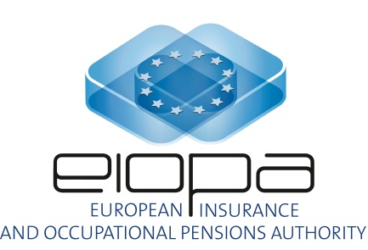

EIOPA REGULAR USE

EIOPA-IRSG-16/03
19 02 2016

Insurance and Reinsurance Stakeholder Group

Short questionnaire about the equity dampener

From January 2015, EIOPA has been publishing on its website information about the symmetric adjustment of the equity capital charge (aka Equity Dampener).
1. What is, in general, your experience on this publication?
IRGS: The transparent publication of the calculation of the symmetric adjustment is welcomed by firms. In contrast with the risk-free rate which is relevant to substantially all life firms, the equity dampener is relevant only to some firms (although for some of these it may be quite material).
2. Is there anything you miss in the publication (taking into account EIOPA is not allowed to publish raw data from our providers) that might useful for your business requirements?
IRSG: There have been difficulties with exact replication of the EIOPA calculations, and it is not clear why. Unambiguous definition of the sources for index constituents – for example by reference to specific data providers - could help reduce an area of ambiguity.
3. Have you used this information for your preparatory calculations for Solvency II?
IRSG: The EIOPA publication has been widely used by firms during the preparatory phase, and particularly by those for whom it is material to calculation of SCR.
4. Have you been able to replicate the calculation from both the EIOPA Equity index and the Symmetric Adjustment?
IRSG: Firms have been able broadly to replicate the calculations, but with small discrepancies the reason for which is not clear. It is possible that such admittedly minor discrepancies arise either from sources or from some element of judgement within the calculations which is not fully transparent within the spreadsheet (or from both of these). An example of the latter could be the number of working days used in calculation of the average. Although the differences are in no case material to assessment of solvency, it is desirable that EIOPA engage with representative practitioners to seek to eliminate any element of ambiguity.
5. If not, could you explain the most important difficulties/doubts to carry out the replication?
IRSG: This matter is probably best pursued in a workshop with practitioners from firms. IRSG members will be able to suggest possible invitees. Such a workshop is not at all urgent, but should prove to be helpful both to EIOPA and to interested firms. It is possible that unambiguous clarification of sources and of how these are accessed may eliminate the ambiguity without need for a workshop.
6. Finally, what do you think about the methodology to calculate the EIOPA Equity index (taking into account the formula for calculating the symmetric adjustment is legally binding)?
IRSG: The IRSG suggests that at some point it may be appropriate for EIOPA to consider the relative merits and practicality of calculating its ‘own’ index as apposed to use/endorsement of a recognised index such as the MSCI World Index or something similar. The advantage to EIOPA of selecting (subject always to regular review of appropriateness) an existing external index is that issues of replicability largely fall away. On the other hand such an index would be only tenuously linked to the equity asset mix of life insurance firms generally. EIOPA has preferred to calculate its ‘own’ index as better reflecting the mix of life insurer equity assets. However this worthy objective may be illusory at the level of any specific firm, and firms might therefore find it more practically useful if EIOPA endorsed from time to time an existing index. The balance of these considerations might appropriately be reviewed after more experience has been gained in 2017 or later.

